­

What do you WANT to be better about it?

K stands for what you already KNOW about drawing something specific

**W** stands for what you WANT to get better at drawing

**H** stands for figuring out HOW you can learn more about how to draw it better

**L** stands for what you LEARNED about how to draw something specific even better!

What were your steps to getting better at drawing it?

What did you get better at drawing?

What do you KNOW is good about it?

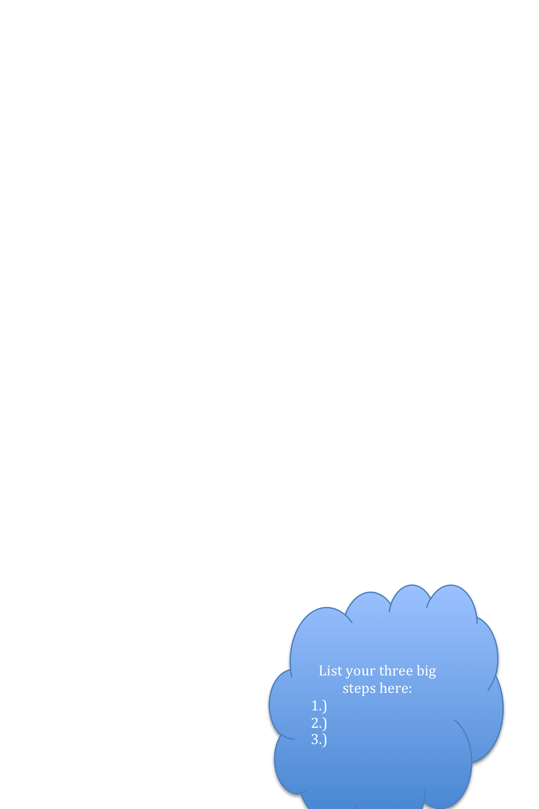

Write or doodle the part you are struggling with here:

Write or doodle the part you are good at here:

List your three big steps here:

1.)

2.)

3.)

Write or doodle what you accomplished

here:

My Know Want Learn Chart:

Learning How to Draw Something Better!